**Eagle 5**

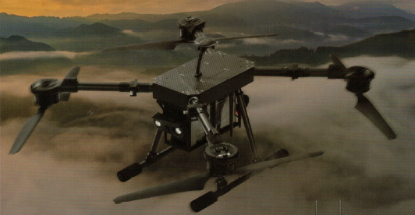**Specification**

***Technical***

No payload weight 10 kg

Full payload weight 15 kg

Dimension in operation 1220 x 1210 x 400 mm

Dimension when folded 490 x 465 x 400 mm

Hovering accuracy (optimal GNSS signal) ± 2.0 m ( horizontal)

Operating frequency 5.745 + 5.825 gHz

No payload flight time 35 minutes

Full payload flight time (5 kg) 17 minutes

Maximum transmission range

(no static, no obstacle) 5 km

Maximum wind resistance 3 m/s

Operation temperature 0 *o* + 40 *o*  C

***Handheld Controller***

Screen 5.5-inch LCD Touchscreen

OS Android 9.0 OS / 2GB RAM / 16 GB ROM

Operation duration 13 hrs

Dimension when folded 189 x138 x 41 mm

Weight 850 g

Water resistance level IP53

Operatable temperature -10 *o* + 50 *o* C

Operating frequency 5.745 + 5.825 gHz

Maximum transmission range

(no static, no obstacle) 15 km

***Usage***

The Eagle 5 is unique combination of advanced features that makes it a versatile tool for a wide range of surveillance and reconnaissance applications. From border patrol and law enforcement to environmental monitoring and disaster relief, the drone's capabilities can be tailored to meet diverse operational needs.

***Target Detection System***

Maximum target recognition distance, mm 400

Target type People, car

Maximum tracking speed, km/h 70

***GIMBAL***

Direction angle, degrees *± 290o*

Range angle, degrees *-100 ~ +45*

Angular error, degrees *± 0.02o*

***GROUND CONTROL STATION***

Operating frequency, GHz 2,4

Maximum transmission range, km 15

Screen size, inches 5.5

Screen resolution 1920 x 1080

Memory, GB 16

Connection Method Wifi, Bluetooth 5.1

***Camera***

Zoom 36x

Resolution 1280x720

Frame rate, fps 30

Video format MP4