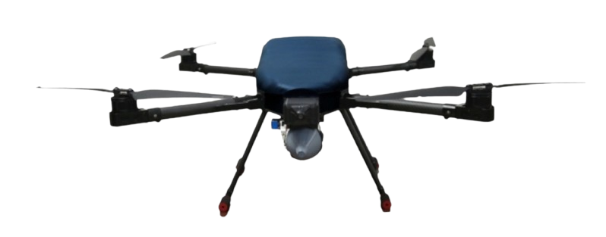**Eagle 7**

**Specification**

***Technical***

Dimensions when operating, mm 1740x1600x500

Dimensions when folded, mm 620x560x500

No Payload weight, kg 13,5

Full payload weight, kg 20,5

Hovering accuracy (optimal GNSS signal) ±2.0 m (horizontal)

No payload flight time 35 minutes

Full payload flight time (7kg) 17 minutes

Maximum transmission range

(no static, no obstacle) 5 km

Maximum wind resistance 3 m/s

Operation temperature 0 *o* + 40 *o*  C

***Handheld Controller***

Screen 5.5-inch LCD Touchscreen

OS Android 9.0 OS / 2GB RAM / 16 GB ROM

Operation duration 13 hrs

Dimension when folded 189x138x41 mm

Weight 850 g

Water resistance level IP53

Operatable temperature -10 *o* + 50 *o* C

Operating frequency 5.745 + 5.825 gHz

Maximum transmission range

(no static, no obstacle) 15 km

***Usage***

Unmanned aerial vehicle carry firepower to equip infantry for air assaults,

used to destroy manpower targets and armored vehicles fixed on the ground.

at combat altitudes 100 to 500 m.

***Camera***

Zoom 36X

HD resolution 1280x720

Frame rate, fps 30

Video format MP4

***Controller***

Operating frequency, Ghz 2,4

Maximum transmission range, km 15

Screen size 5.5 inch

Screen resolution 1920x1080

Memory 16GB

Connection Wi-Fi, Bluetooth 5.1

***Target Recognition System***

Maximum target recognition distance, mm 400

Target type People, cars

Maximum tracking speed, km/h 70

***GIMBAL***

Orientation angle, degrees ±290

Radial angle, degrees -100 ~ +45

Angular error, degrees ±0.02

***Combat Module***

**Thermobaric explosive head dropping module**

* Weight, not greater than, kg 0.5
* Number of integrated explosive heads 1
* Control accuracy of dropping the explosive head on a fixed target

(at an altitude of 100-500m), not greater than, m 10

**Anti-personnel explosive head dropping module**

* Weight, not greater than, kg 0.5
* Number of integrated explosive heads 1
* Control accuracy of dropping the explosive head on a fixed target

(at an altitude of 100-500m), not greater than, m 10

**Concave piercing explosive head dropping module**

* Weight, not greater than, kg 1
* Number of integrated explosive heads 1
* Control accuracy of dropping the explosive head on a fixed target (at an altitude of 100-500m), not greater than, m 10